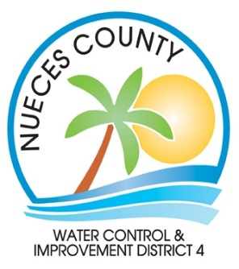
Backflow Inspection Authorization Form
I authorize Nueces County Water Control and Improvement District 4 to hire a private contractor to inspect my backflow prevention device on an annual basis.
This contractor (Affordable Backflow) will have access to my private property in order to conduct this inspection and may be given my contact information.
I understand that I will be charged a testing fee and administration fee to be reflected on my statement.

Customer Name: ______________________________________ Account #: ______________
Phone #: ____________________________ Email: ___________________________________
Service Address: _______________________________________________________________
Billing Address: ________________________________________________________________
________________________________________________________________
________________________________________________________________

Signature: _________________________________ Date: ________________________

Please return completed form to:
Nueces County Water District 4
1812 SH 361; Suite F
Port Aransas, TX 78373
OR
Email: info@ncwcid4.org
Fax: (361) 749-5799

